|  |
| --- |
| Bachkhoa aptech |
| Review Document Eproject |
| Radio Cabs |
|  |
| **Group 2 – C1012L** |
| **[Pick the date]** |

|  |
| --- |
| [Type the abstract of the document here. The abstract is typically a short summary of the contents of the document. Type the abstract of the document here. The abstract is typically a short summary of the contents of the document.] |

1. **DFD**
2. DFD Level 0

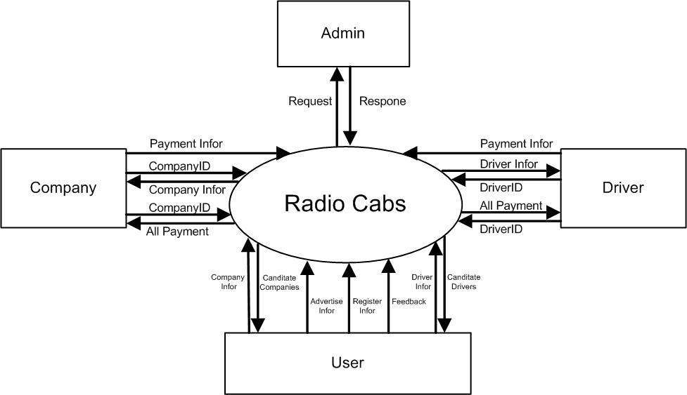

1. DFD Level1

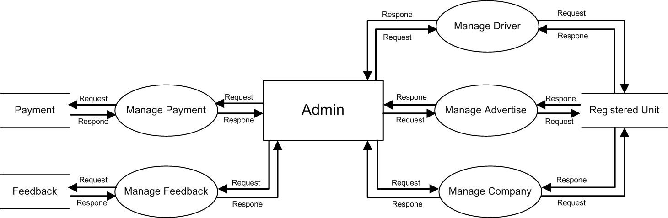

**DFD Level 1 Admin**

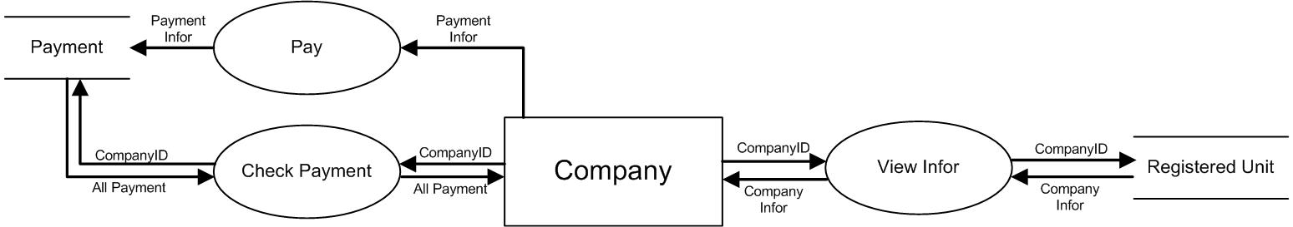

**DFD Level 1 Company**

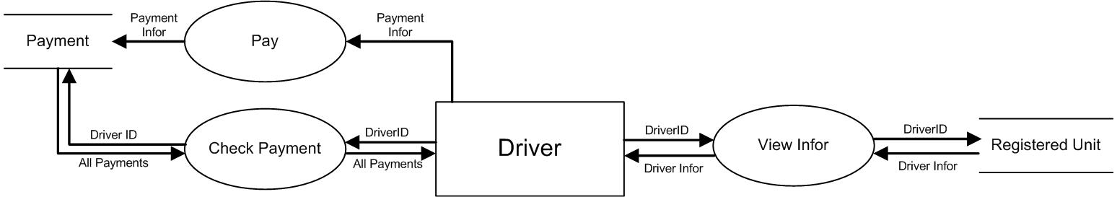

**DFD Level 1 Driver**

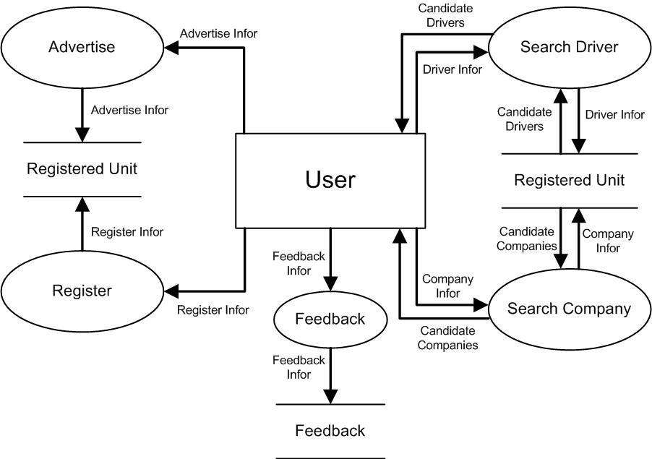

**DFD Level 1 User**

1. **ERD**



1. **Database**

